Date:
Name
Grade Level |  | Inspection Grade |  | _____/100
Period |  | Knowledge Grade |  | _____ /15
 | Present/ Absent |  | Absent ______/100
 | No Uniform |  | No Uniform_______/75
Mastery: 90-100 Met Expectations: 79-89 Below Expectations: 65-78 Failing: 64 and Below
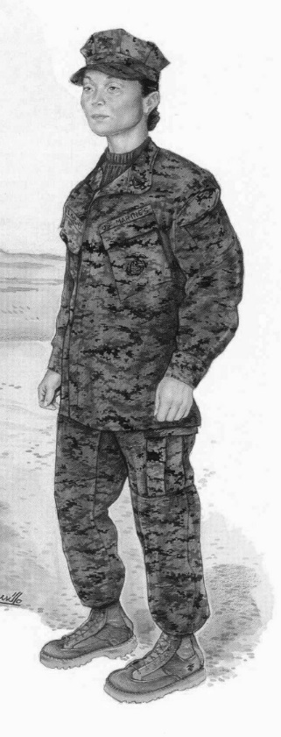 | Inspection Element | Max | Average | Min
 | Cover
 | - Improperly Worn | -3 | -2 | -1
 | - Wrinkled | -3 | -2 | -1
 | - Irish Pennants, (IP’s) | -3 | -2 | -1
 | Shave
 | - Did Not Shave | -10 | -6 | -2
 | Haircut/Hair | -20 | -10 | -2
 | Blouse/Shirt
 | - Dirty/Wrinkled/ Irish Pennants | -5 | -3 | -1
 | - Sleeves 3”/ Elbow 1” | -5 | -3 | -1
 | - Chevron Improper Placement | -5 | -3 | -1
 | - Chevron Worn/Dirty | -3 | -2 | -1
 | Green T-Shirt | -5 | -3 | -1
 | Trousers
 | - Dirty/Wrinkled/ IP’s | -5 | -3 | -1
 | Belt
 | - 2”-4” Measurement | -5 | -3 | -1
 | Boots
 | - Dirty/Irish pennants | -3 | -2 | -1
 | - Shoe laces/Improper blouse | -3 | -2 | -1
 | Hands
 | - Dirty/Fingernails | -5 | -3 | -1
 | Knowledge
 | - Reporting procedure | -7 | -5 | -3
 | 17.Bearing/Appearance | -10 | -5 | -3
 | Knowledge
 | Three Questions | 5 | 5 | 5
All numbers are negative, only circle the appropriate unsatisfactory grade if any. Add total negative grades and subtract from 100 to get overall Cadet Inspection grade.

