**Library Resource Guide**

**Dual Credit Comp. II - Biographical Analysis Paper**

**Step 1: Access Destiny Discover App on iPad & Log In**

**Step 2: Find information with Catalog Resources and/or databases** 

*All ebooks, databases, and newspapers are password protected. Find the password you need by clicking the password icon located on the Destiny Discover homepage.

[CLICK HERE TO ACCESS PASSWORDS NOW](https://docs.google.com/spreadsheets/d/1jN5OArW00Vf1Bls9ZB-VKWRRASWoTBP0X1C6tijbfcU/edit?usp=sharing)



* [**Destiny Discover - LIBRARY CATALOG**](https://search.follettsoftware.com/metasearch/ui/36089)
  + **Log in with OSD username and password**
  + [**View Collection - Dual Credit Eng. Comp. II**](https://collections.follettsoftware.com/collection/636116281e7ee8001254f425)
  + **Search for a keyword related to the topic**
  + **Select a Title & “View More Details” to locate “Citations”**
  + Click OPEN for ebooks
  + Thousands of ebooks
    - Read the chapter headings or use the table of contents/index to find information quickly
  + Ebook passwords

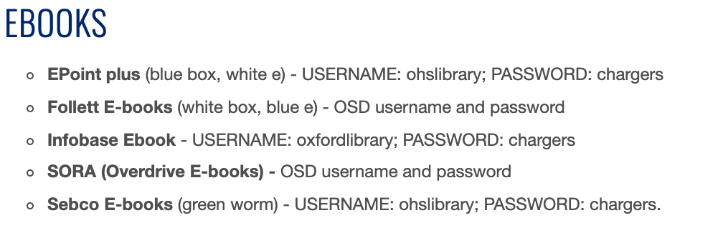

* **Search for a topic and use the “Websites” tab to find external links to educational content on the web.**

* [**Databases - access links in Destiny Discover - “Learning Resources”**](https://search.follettsoftware.com/metasearch/ui/36089)
  + **Encyclopedia Britannica -** 
  + username and password - oxfordis
    - Search by keyword
    - Use the TABS within articles to find related images and related websites
    - Use the TOOLS to cite and send/save the article



* + **Salem Press Reference Database** 
    - Automatic login on OHS campus
    - Use the SEARCH for specific people
    - Look under HISTORY
      * *Great Athletes*
      * *Great Lives from History*
* Use the TOOLS to cite and send/save the article
* **MAGNOLIA** 
* Automatic login on OHS campus
* From home use the password: magn0897
  + Click - Search Databases
  + Find - Grade Level High School
  + SEARCH ALL DATABASES & LOCATE MAS SCHOOL EDITION
  + Refine your results by publication types to include only BIOGRAPHIES or magazines and newspapers
  + Read the title, annotation, and subject headings (this tells you what the article is about before you read)
  + Use the TOOLS to cite and send/save the article

**Ms. Osborne** [**atosborne@oxfordsd.org**](mailto:atosborne@oxfordsd.org)