**Library Resources for Marine and Aquatic II**

[**Project Descriptions**](https://docs.google.com/document/d/1ohve2trzbbP-C0We9gs53TH-oWKFldM41kRuvQJUY4E/edit?usp=sharing)

**Step 1: Access Destiny Discover App on iPad & Log In**

**Step 2: Find information with Catalog Resources and/or databases**

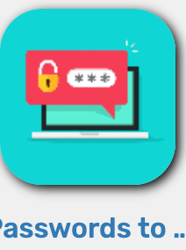

*All ebooks, databases, and newspapers are password protected. Find the password you need by clicking this icon on the Destiny Discover homepage.

*You must sign in at the top of the page to view the password.

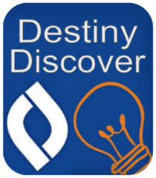

* **Destiny Discover - LIBRARY CATALOG** 
  + **Log in with OSD username and password**
  + **View Collection - Marine & Aquatic II**
  + **Search for a keyword related to the topic**
    - **Example: Fish**
  + Click OPEN for ebooks
  + Lightbox Ebooks are interactive and open automatically
  + Thousands of ebooks
    - Read the chapter headings or use the table of contents/index to find information quickly
  + Ebook passwords

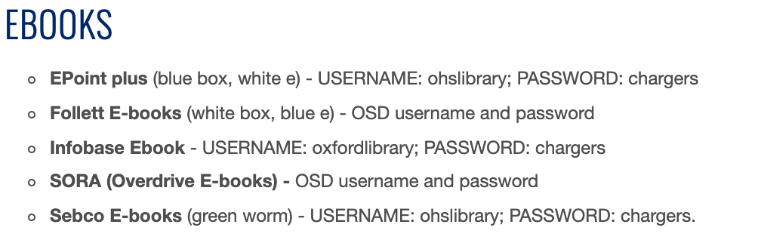

* **Search for a topic and use the “Websites” tab to find external links to educational content on the web.**

* **Databases - access links in Destiny Discover - “Learning Resources”**
  + **Encyclopedia Britannica -** 
  + username and password - oxfordis
    - Search by keyword
      * Ecosystem - Coral Reef
    - Use the tabs within articles to find related images and related websites
  + **Gale in Context: SCIENCE**
  + Sign in - Oxford
    - On the homepage, search for your ecosystem and/or environmental issue 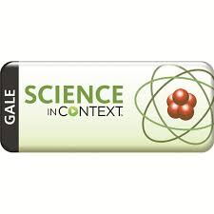
      * Ecosystem - Beach
      * Marine Organism - Coral Reef

View the Gale Science Videos to learn how to use the database:

* + - Overview: <https://support.gale.com/doc/ICSci-acad-tutorial>
    - Topic Pages: <https://support.gale.com/doc/scic-video1>
    - MLA Citations: <https://support.gale.com/doc/galetools-video1>
    - Tools:: <https://support.gale.com/doc/galetools-video7>
    - Send to Google Drive: <https://support.gale.com/doc/galetools-video3>
    - Highlights and Notes: <https://support.gale.com/doc/galetools-video2>
* **Magnolia -** 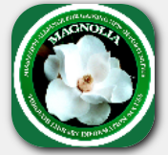
* Automatic login on OHS campus
* From home use the password: magn0897
  + Click - Search Databases
  + Find - Grade Level High School
  + Use - Explora
    - [Learn how to use Explora](https://youtu.be/giCmSPS6Uqs)
  + Refine your results by copyright to include only the last 10 years - 2012-2022
  + Refine your results by publication types to include only magazines and newspapers
  + Read the title, article summary, and subject headings (this tells you what the article is about before you read)

|  | *Encyclopedia Britannica | *Gale  Science | *Magnolia -  Automatic Login on OHS Campus  @ home use the passcode: magn0897 | *Ebook - Passwords  vary | Book | Websites |
| --- | --- | --- | --- | --- | --- | --- |
| Marine Organism Research Paper & Digital Poster & Model | X | X | X | X | X | X |
| Marine Organism Digital Poster & Presentation | X | X | X | X | X | X |
| Make a Model & Presentation | X | X | X | X | X | X |
| Marine Ecosystem Project | X | X | X | X | X | X |

**Have a Question/Need help??? Email Ms. Osborne** [**atosborne@oxfordsd.org**](mailto:atosborne@oxfordsd.org)